भारतमौसमविज्ञानविभाग |  | India Meteorological Department
Tuesday,10th June 2025 (20 Jyeshtha 1947 Saka)
Summary of observations recorded at 0830 hours IST: The Northern Limit of Monsoon continues to pass through 17.0°N/55°E, 17.5°N/60°E, 18°N/65°E, 18.5°N/70°E, Mumbai, Ahilyanagar, Adilabad, Bhawanipatna, Puri, Sandhead Island, 23.5°N/89.5°E, Balurghat, 30°N/85°E. Conditions are favourable for advance of Monsoon over some more parts of Central and adjoining East India around 14th June. The trough from the cyclonic circulation over northwest Uttar Pradesh and neighbourhood to Telangana northwest Uttar Pradesh to west central Bay of Bengal across north Madhya Pradesh, south Chhattisgarh and central Odisha at 0.9 km above m. s. l. The trough from north Tamil Nadu to south Maharashtra coast across Interior Karnataka lay as a shear zone roughly along Lat. 15°N over the Indian Region between 3.1 and 4.5 km above m. s. l. The upper air cyclonic circulation over northwest Uttar Pradesh and neighbourhood lay over north Haryana & neighborhood at 1.5 km above m. s. l. The upper air cyclonic circulation over northwest Bay of Bengal and adjoining north coastal Odisha & south Gangetic West Bengal lay over north Odisha & neighbourhood between 1.5 & 5.8 km above m. s. l. tilting southwards with height. The Western Disturbance as a trough in middle tropospheric westerlies with its axis at 5.8 km above m. s. l. ran roughly along Long. 62°E to the north of Lat. 28°N. An upper air cyclonic circulation lay over north Chhattisgarh and neighborhood at 0.9 km above m. s. l. An upper air cyclonic circulation lay over north Pakistan & neighborhood off Punjab at 1.5 km above m. s. l. An upper air cyclonic circulation lay over central parts of south Uttar Pradesh & neighborhood at 1.5 km above m. s. l. The upper air cyclonic circulation over southeast & adjoining eastcentral Bay of Bengal lay over central parts of Bay of Bengal between 5.8 & 7.6 km above m. s. l. today morning. It became less marked.
Day temperatures were markedly above normal at most places over Arunachal Pradesh; at few places over Assam & Meghalaya, Jammu-Kashmir-Ladakh-Gilgit-Baltistan-Muzaffarabad and East Madhya Pradesh; at isolated places over Sub Himalayan West Bengal & Sikkim, East Uttar Pradesh, Haryana-Chandigarh-Delhi, Himachal Pradesh, West Madhya Pradesh and Coastal Andhra Pradesh & Yanam. appreciably above normal (3.1°C to 5.0°C) at most places over Bihar and Punjab; at few places over West Uttar Pradesh and West Rajasthan; at isolated places over Nagaland, Manipur, Mizoram & Tripura, Gangetic West Bengal, Odisha, Uttarakhand, East Rajasthan, Vidarbha, Tamil Nadu, Puducherry & Karaikal and Kerala & Mahe. above normal (1.6°C to 3.0°C) at few places over Lakshadweep; at isolated places over Jharkhand, Saurashtra & Kutch and Chhattisgarh. near normal (-1.5°C to 1.5°C) at many places over Andaman & Nicobar Islands, Madhya Maharashtra, Marathwada and South Interior Karnataka; at most places over Gujarat Region, Konkan & Goa and Coastal Karnataka; at few places over Telangana, Rayalaseema and North Interior Karnataka. The highest maximum temperature of 47.3°C was reported at Sriganganagar (Rajasthan).

The Southwest Monsoon has been subdued over Arunachal Pradesh, Assam & Meghalaya and coastal Andhra Pradesh.
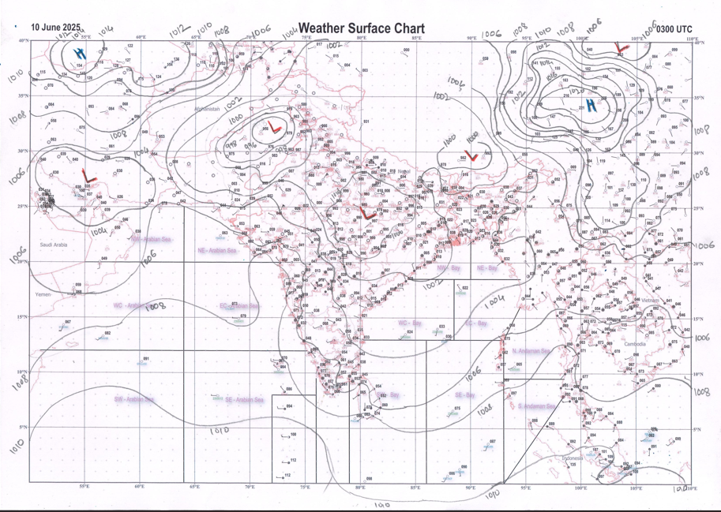 | 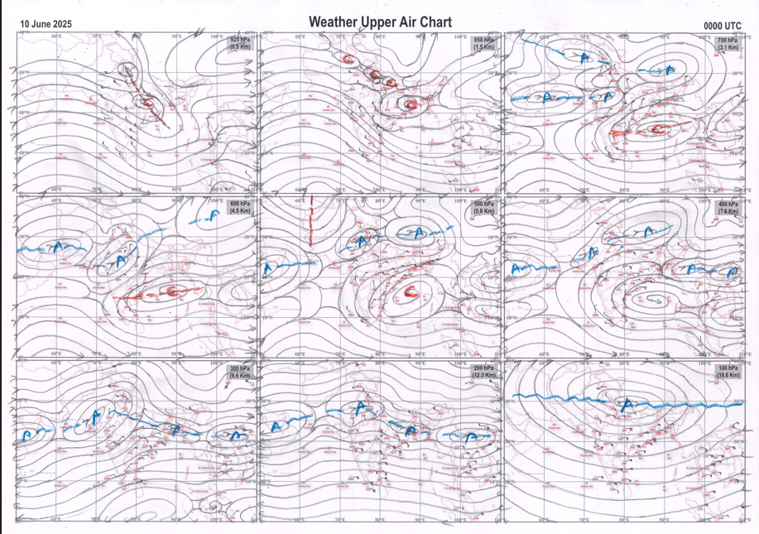
g.1. Analysed surface chart based on 03z observation | Fig.2. Analysed upper air chart based on 00z observation

Dr. S.D.Sanap
Scientist ‘D’
CR & S Office, Pune  Issued at 1245 hrs. IST |  | Weather Forecasting Division  CR&S, Pune

Indian regions | Realised rainfall (chief amount in cm during past 24 hrs):
East | many places: Odisha+  isolated places: Assam & Meghalaya, Nagaland-Manipur-Mizoram-Tripura, West Bengal & Sikkim and Jharkhand  dry weather: Arunachal Pradesh and Bihar  Chikiti 9.4, Akhuapada 7.7, Saiha AWS 6.4, Chakulia 3.9, Angul 3.8, Champai AWS 2.9, Midnapore 2.5, Mawphlang 2.3, Midnapore (CWC) 1.9, Hatgamharia 1.5, Ranchi AP 1.2, Dentam 1.1, Aizwal 1.0, Dalgaon ARG 0.7, Buxaduar 0.6, Mohanpur 0.4.
North | isolated places: Uttarakhand  dry weather: Uttar Pradesh, Haryana, Punjab, Himachal Pradesh, Jammu-Kashmir and Ladakh and Rajasthan  Loharkhet 3.1, Sama 1.2, Dharchula 0.5.
Central | isolated places: west Madhya Pradesh◆, east Madhya Pradesh, Vidarbha and Chhattisgarh  Zarizamni 4.0, Korpana 3.2, Deobhog 1.5, Dondilohara 1.0, Balaghat-aws 0.7, Pusad & Rajnandgaon 0.4 each, Sanwer, Barwaha & Birsa 0.2 each.
Peninsula | a few places: Marathwada+, Tamil Nadu+, coastal Karnataka and interior Karnataka  isolated places: Gujarat Region◆, Konkan & Goa, Madhya Maharashtra, coastal Andhra Pradesh, Telangana, Rayalaseema and Kerala  dry weather: Saurashtra & Kutch  Kandhar 8.5, Loha 8.1, Perambalur 7.5, Kollidam 6.4, Adilabad 5.4, Yeda palle 5.2, Pathapatnam 4.9, Alladurg & Almel ARG 4.6 each, Parvathipuram & Kunnamkulam 4.5 each, Gorantla 4.3, Aurad 4.0, Hindupur & Vedaranyam 2.9 each, Bargur 2.7, Bidar PTO 2.6, Quepem, Udgir IMD parttime & Mangaluru 2.5 each, Sira 2.4, Tasgaon 2.2, Bengaluru HAL AP 2.0, Vaibhavwadi & Vaikom 1.7 each, Karkala 1.4, Kalingapatnam 1.1, Mangaluru AP 0.9, Barshi 0.8, Kochi IAF 0.6, Sangli 0.5, Ratnagiri 0.3, Bodeli & Kaprada 0.1 each.
Islands | many places: Andaman & Nicobar  a few places: Lakshadweep  Hut bay 2.2, Port blair 1.4, Long island 0.7, Amini 0.6, Agathi 0.1.
Table 2. Forecast / warnings (distribution of rain / thundershowers) for 7 days (valid from time of origin upto 0830 hrs IST of next day)
Sr. No |  | Sub-division Name | Day 1 | Day 2 | Day 3 | Day 4 | Day 5 | Day 6 | Day 7 | Sr. No. | Sub-division Name | Day 1 | Day 2 | Day 3 | Day 4 | Day 5 | Day 6 | Day 7
 |  |  | 10 Jun | 11 Jun | 12 Jun | 13 Jun | 14 Jun | 15 Jun | 16 Jun |  |  | 10 Jun | 11 Jun | 12 Jun | 13 Jun | 14 Jun | 15 Jun | 16 Jun
 | 1 | Andaman Nicobar Islands | W  | W  | W+  | F | F | F | F | 19 | west Madhya Pradesh | I + | I + | I+ | I  | I  | S | S 
 | 2 | Arunachal Pradesh | I  | S  | S +  | F +  | F +  | F + | F +  | 20 | east Madhya Pradesh | I + | I + | I+ | I  | I  | S | S 
 | 3 | Assam-Meghalaya | S  | F +  | S +  | S +  | S +  | F + | F +  | 21 | Gujarat region | I | I | I | I | I | I | I
 | 4 | Nagaland-Manipur-Mizoram-Tripura | F +  | F +  | S +  | S +  | F +  | F + | F +  | 22 | Saurashtra and Kutch | I | I | I | I | I | I | I
 | 5 | Sub Himalayan West Bengal/Sikkim | I + | S  | F  | F +  | F +  | F + | F +  | 23 | Konkan and Goa | S  | S  | F ++ | W # | W # | W ++ | W#
 | 6 | Gangetic West Bengal | I + | S + | F  | F  | F  | F | F  | 24 | Madhya Maharashtra | I +  | I +  | S ++ | S ++  | F ++ | W++ | W++
 | 7 | Odisha | S ++ | S + | S  | S  | S + | S + | S + | 25 | Marathwada | S  | S + | S + | F +  | F + | S | S +
 | 8 | Jharkhand | I  | S  | S  | S  | F  | F | F  | 26 | Vidarbha | I  | S  | S  | S  | F  | F | F 
 | 9 | Bihar | I + | S + | F  | S  | S  | S | S  | 27 | Chhattisgarh | I  | I  | S  | S  | S + | S | S +
 | 10 | east Uttar Pradesh | D + | I + | I  | S  | S  | S  | I  | 28 | Coastal Andhra Pradesh and Yanam | I +  | F+  | F+ | S  | I  | I | I 
 | 11 | west Uttar Pradesh | D + | D + | I + | I  | I  | S  | S  | 29 | Telangana | S +  | S +  | F + | F  | F  | S | S 
 | 12 | Uttarakhand | I  | S  | F +  | F+  | F +  | F + | F +  | 30 | Rayalaseema | S | W + | W + | F | I | I | I
 | 13 | Haryana,Chandigarh and Delhi | D + | D + | D + | I  | I  | I  | S  | 31 | Tamil Nadu, Puducherry and Karaikal | S +  | S +  | S+ | S++ | S # | S # | S #
 | 14 | Punjab | D + | D + | D + | D + | I  | I  | I  | 32 | Coastal Karnataka | W +  | W +  | W # | W # | W # | W # | W #
 | 15 | Himachal Pradesh | D + | D + | D + | I  | I  | S  | S  | 33 | North interior Karnataka | F +  | F +  | W++ | W # | W ++ | W ++ | W ++
 | 16 | Jammu-Kashmir and Ladakh | D + | D + | D + | I  | I  | I | I  | 34 | South interior Karnataka | W +  | W+ | W # | W # | W # | W ++ | W # +
 | 17 | west Rajasthan | D + | D + | D + | D + | D+ | D  | D + | 35 | Kerala and Mahe | W +  | W + | W++  | W ++  | W # | W # | W #
 | 18 | east Rajasthan | D + | D + | D + | D + | I | I | I | 36 | Lakshadweep | W  | W  | W  | W +  | W +  | W | W + 
Legends: D = DryI = IsolatedS = ScatteredF = Fairly widespreadW = Widespread #= heavy to very heavy rain at a few places with extremely heavy rain at isolated places +++= heavy rain at a few places with very heavy rain at Isolated places ++= heavy to very heavy rainfall @=Isolated exceptionally heavy rainfall + = heavy rain ●/*= rain or snow ♦ = very light rain ≡=fog= thunderstorm with lightning =Squall / Gusty / gale / strong wind ­ =cold wave/cold day += heat wave/warm night/hot and humid weathe r=Duststorm =ground frost = Hail
Fig. 4: Districtwise warnings for five days for Maharashtra State
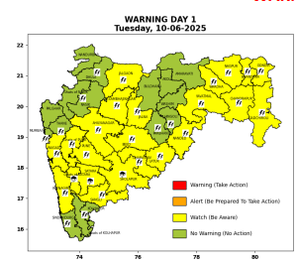 | 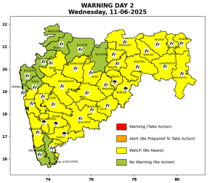 | 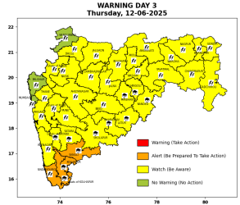 | 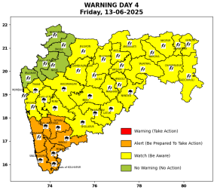 | 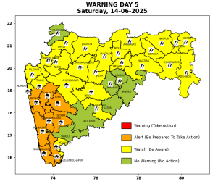

Pune, Lohegaon and Pashan observations at 0830 hrs. IST of Today
 | Temperature (°C) |  |  |  |  | Humidity (%) |  |  |  | Rainfall (mm)
 | Max.  past  24 hrs | Dep.  from  normal | Min.  past  24 hrs. | Dep.  from  normal | Dry  Bulb | At 0830 hrs. IST | Dep.  From  normal | At 1730  hrs. IST of y’day | Dep.  from  normal | Past  24 hrs. | Since  1st June | Dep.  from  normal
PNE | 31.4 | -2.9 | 22.4 | -0.9 | 26.4 | 77 | 0 | 68 | 8 | 0.0 | 38.1 | -15.6
PSN | - | - | 21.3 | - | 24.8 | 84 | - | - | - | 0.0 | 26.3 | -
LHG | 33.5 | 0.5 | 24.6 | 3.6 | 28.0 | 63 | -11 | 58 | 3 | 0.0 | 54.8 | 12.4

 |  |  |  |  |  |  | Local (Pune and neighbourhood) forecast
Max./Min. Temperature (°C) |  |  |  |  |  |  |  |  | Weather
Date | Pune | Pashan | Lohegaon | Chinchwad | Lavale | Magarpatta | NDA | Koregoan Park
10/06/25 | 32/22.4* | 31/21.3* | 33/24.6* | 31/23.7* | 30/- | 33/24.6* | 31/21.7* | 33/24.4* | Partly cloudy sky becoming generally cloudy sky towards afternoon/evening. Thunderstorm with lightning, very light to light rain very likely.
11/06/25 | 33/22 | 32/21 | 35/25 | 31/24 | 30/23 | 34/25 | 31/22 | 33/24 | Partly cloudy sky becoming generally cloudy sky towards afternoon/evening. Thunderstorm with lightning, very light to light rain very likely.
12/06/25 | 31/21 | 30/21 | 33/24 | 30/23 | 29/22 | 32/24 | 30/21 | 31/23 | Generally cloudy sky. Thunderstorm with lightning, moderate to heavy rain very likely.
13/06/25 | 30/21 | 29/21 | 32/24 | 30/23 | 28/22 | 31/24 | 30/21 | 30/23 | Generally cloudy sky. Thunderstorm with lightning, moderate to heavy rain very likely.
14/06/25 | 29/21 | 29/21 | 31/24 | 29/23 | 28/22 | 30/24 | 29/21 | 29/23 | Generally cloudy sky. Thunderstorm with lightning, moderate to heavy rain likely.
15/06/25 | 29/22 | 29/22 | 31/25 | 29/24 | 28/23 | 30/25 | 29/22 | 29/24 | Generally cloudy sky. Thunderstorm with lightning, moderate to heavy rain likely.
16/06/25 | 30/23 | 30/23 | 32/26 | 30/25 | 29/24 | 31/26 | 30/23 | 30/25 | Generally cloudy sky. light to moderate rain likely.
Rainfall Distribution |  |  | Rainfall Categories | Rainfall (mm) |  | Cloud condition |  |  |  | Rainfall Intensity |  | Range
Widespread (W) | 76-100% |  | Very Light rain | Trace to 2.4 mm |  | Mainly clear sky |  | 1-2 oktas |  | Light Spell |  | 1 cm/hr
 |  |  | Light rain | 2.5 to 15.5 mm |  | Partly cloudy sky |  | 3-4 oktas |  | Moderate Spell |  | 1-2 cm/hr
Fairly Widespread (FW) | 51 – 75% |  | Moderate rain | 15.6 to 64.4 mm |  | Generally cloudy sky |  | 5-7 oktas |  | Intense Spell |  | 2-3 cm/hr
Scattered (S) | 26 – 50% |  | Heavy rain | 64.5 to 115.5 mm |  | Overcast |  | 8 oktas |  | Very Intense Spell |  | 3-5 cm/hr
isolated (I) | 1 – 25% |  | Very heavy rain | 115.6 to 204.4 mm |  |  |  |  |  | Extremely Intense Spell |  | 5-10 cm/hr
D (D) | No Rain |  | Extremely heavy rain | ≥ 204.5 mm |  |  |  |  |  | Cloudburst |  | > 10 cm/hr
Probability Terms in %: |  |  | Heavy snow | 6.5 to 11.5 cms water equivalent of rain
unlikely | < 25 |  | Very heavy snow | 11.6 to 20.4 cms water equivalent of rain
likely | between 25 50
very likely | between 51 75
most likely | >75
* = realized temperature
Mumbai (Colaba) |  |  |  | Nagpur (AP)
Date 2025 | T max °C | T min °C | Weather | T max °C | T min °C | Weather
10/06 | 33 | 27 | Partly cloudy sky with one or two spells of rain or thundershowers. | 43 | 28 | Rain or thundershowers accompanied with lightning & gusty winds(40-50kmph).
11/06 | 33 | 27 | Partly cloudy sky with one or two spells of rain or thundershowers. | 38 | 28 | Rain or thundershowers accompanied with lightning & gusty winds(50-60kmph).
12/06 | 32 | 27 | Partly cloudy sky with one or two spells of rain or thundershowers. | 38 | 28 | Rain or thundershowers accompanied with lightning & gusty winds(40-50kmph).
13/06 | 32 | 27 | Partly cloudy sky with possibility of moderate rain or Thunderstorm.  Thunderstorm accompanied with lightning & gusty winds(40-50kmph). | 38 | 27 | Rain or thundershowers accompanied with lightning & gusty winds(40-50kmph).
14/06 | 32 | 26 | Heavy Rainfall. | 37 | 27 | Rain or thundershowers accompanied with lightning & gusty winds(40-50kmph).
15/06 | 32 | 26 | Heavy Rainfall. | 35 | 26 | Generally cloudy sky with possibility of rain or Thunderstorm.
16/06 | 31 | 25 | Heavy Rainfall. | 34 | 26 | Generally cloudy sky with possibility of rain or Thunderstorm.

